Assignment 4: Colorization

# Group Members

* **Harshil Patel:** Improved Agent + Questions
* **Mehul Patel:** Preprocessing + Questions
* **Jonathan Pinto:** Basic Agent + Questions

# Notes about Project

# Questions and Writeup

## The Basic Agent

## The Improved Agent

# Figures

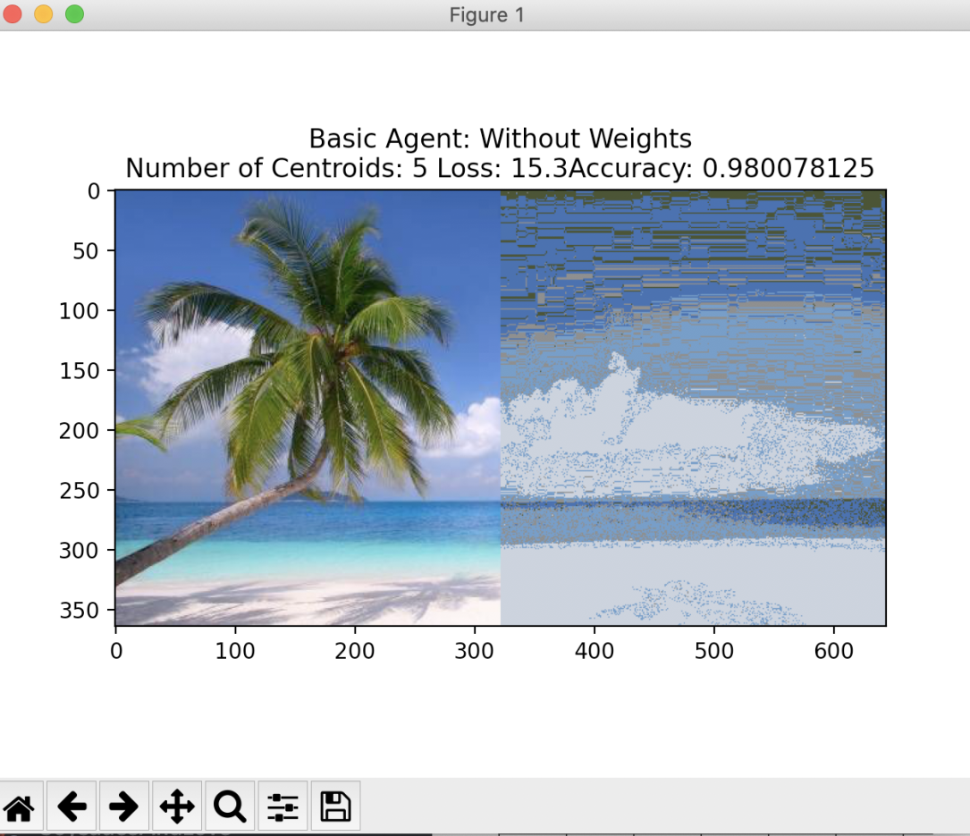

Graph Basic Agent without weights with 5 centroids

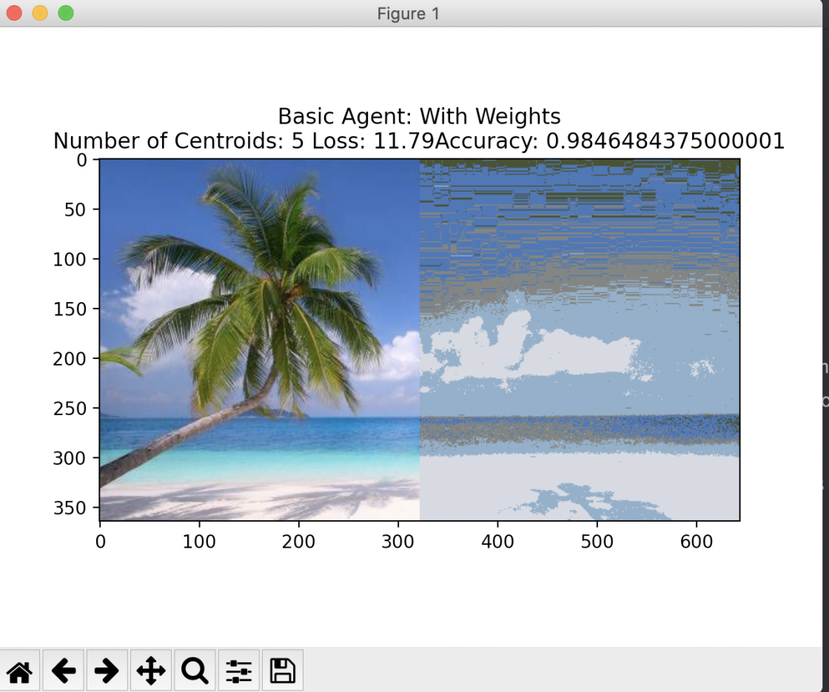

Graph Basic Agent with weights with 5 centroids

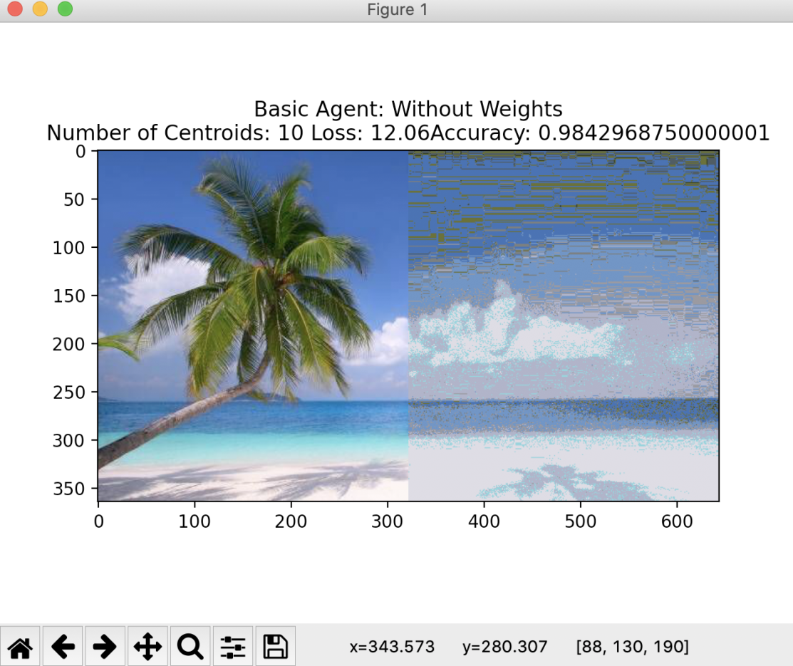

Graph Basic Agent without weights with 10 centroids

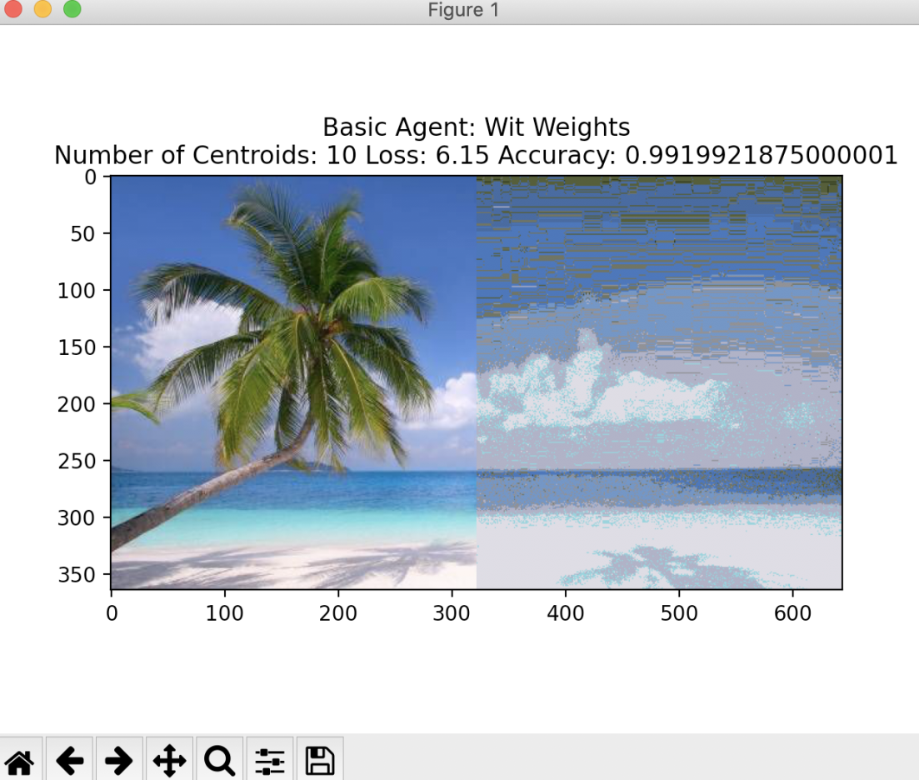

Graph Basic Agent with weights with 10 centroids

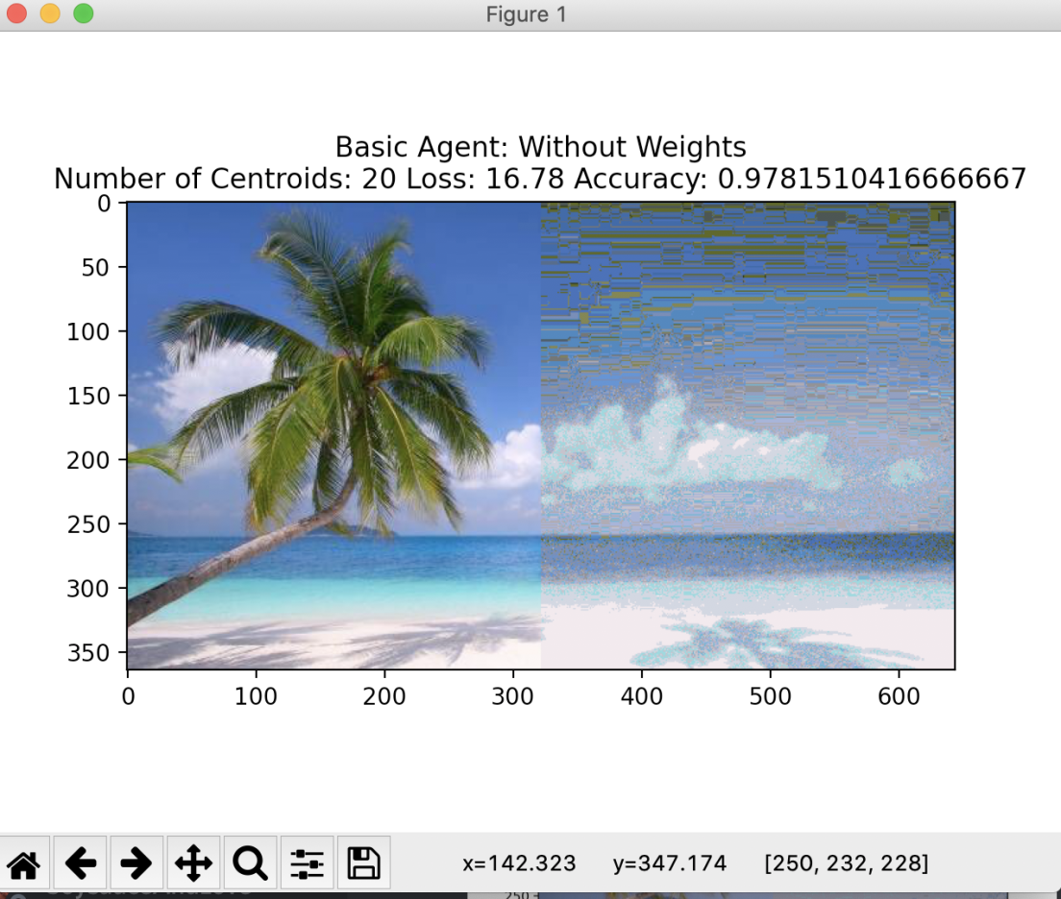

Graph Basic Agent without weights with 20 centroids

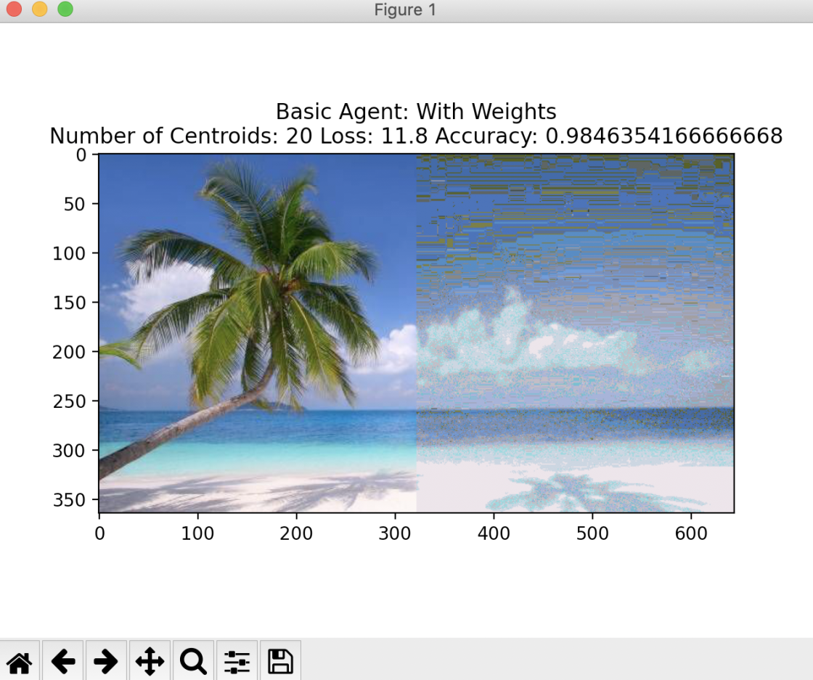

Graph Basic Agent with weights with 20 centroids

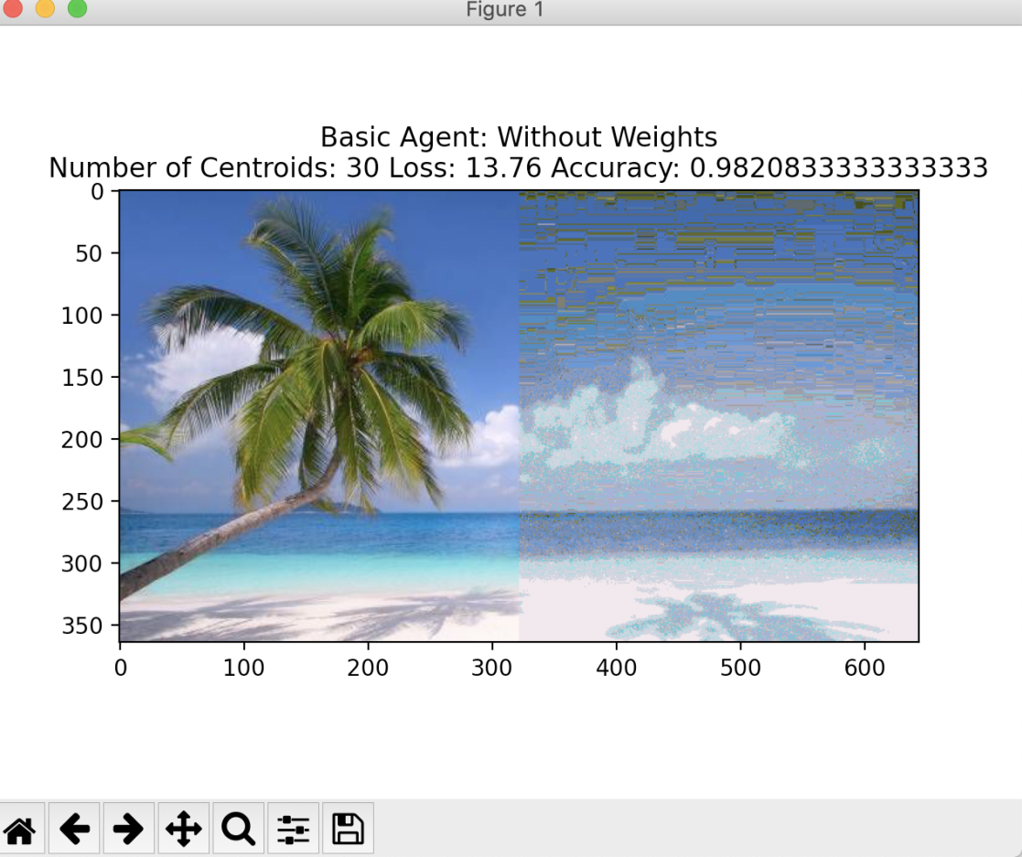

Graph Basic Agent without weights with 30 centroids

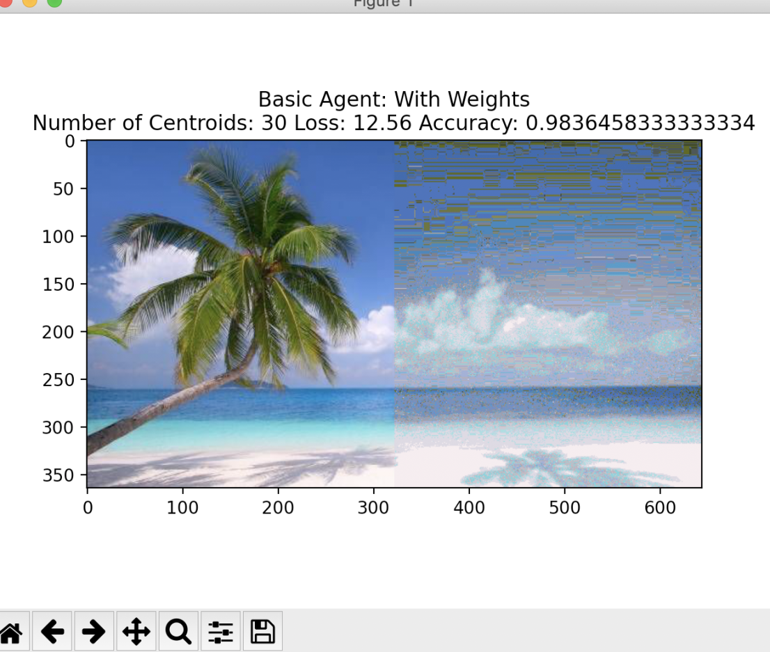

Graph Basic Agent with weights with 30 centroids

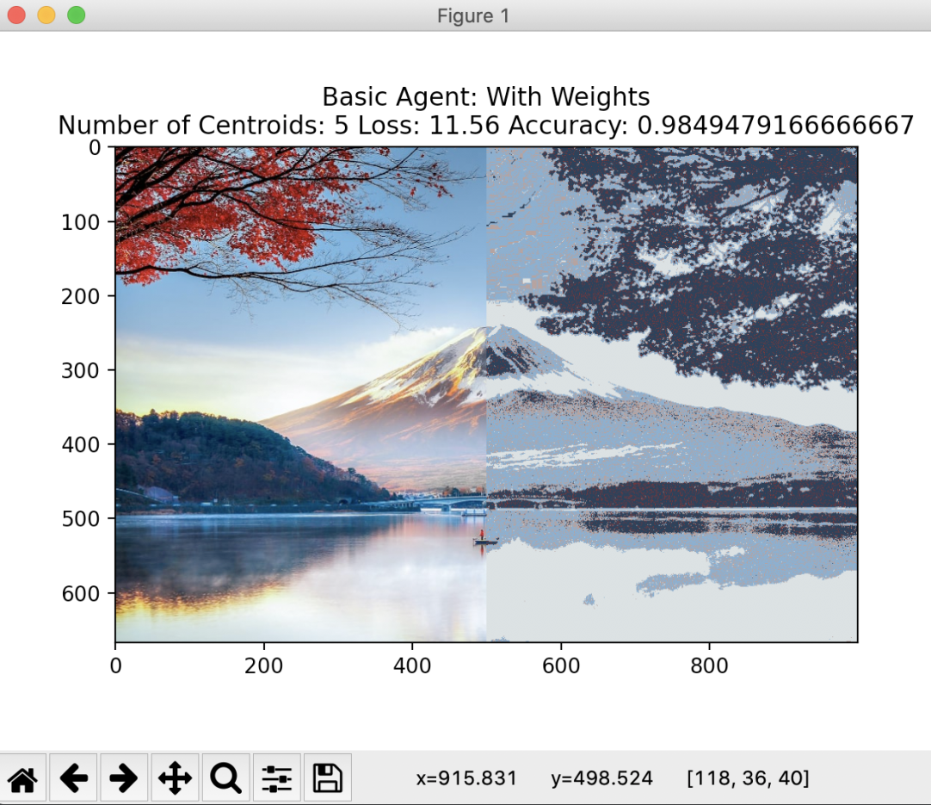

Graph Basic Agent with weights with 5 centroids

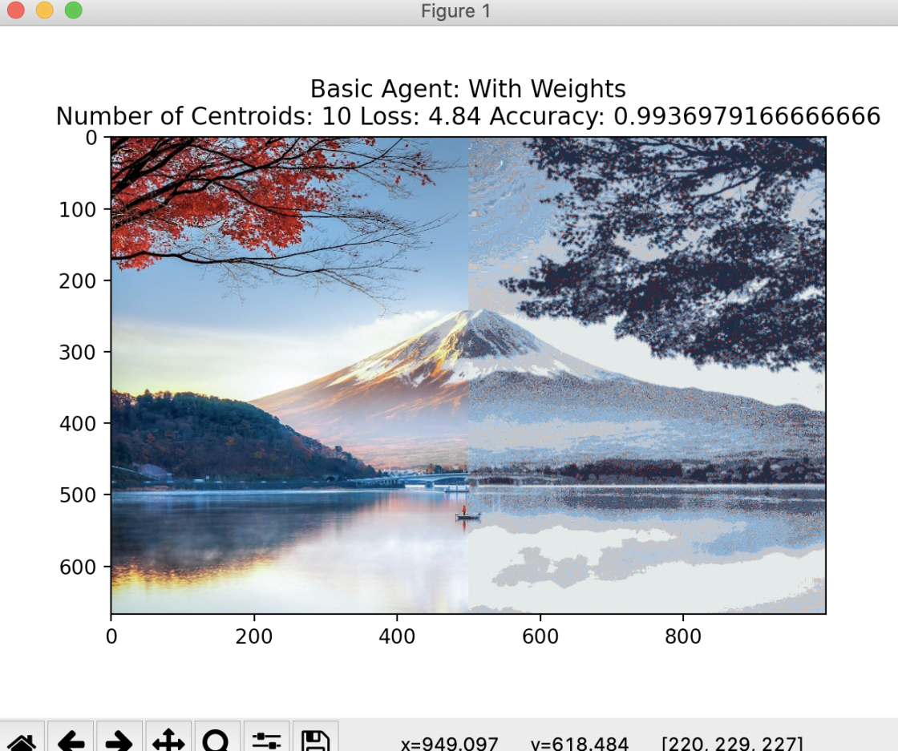

Graph Basic Agent with weights with 10 centroids

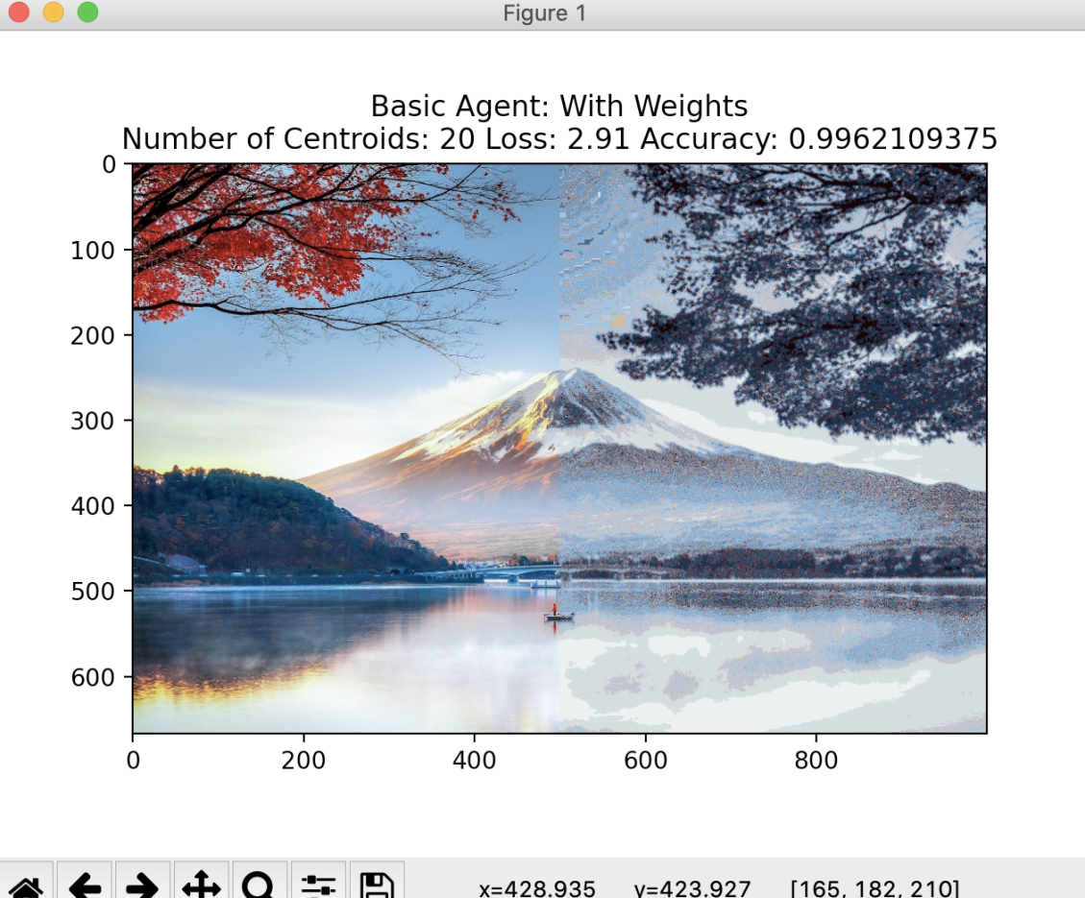

Graph Basic Agent with weights with 20 centroids